Vilnius University

Faculty of Mathematics and Informatics

Computer Science

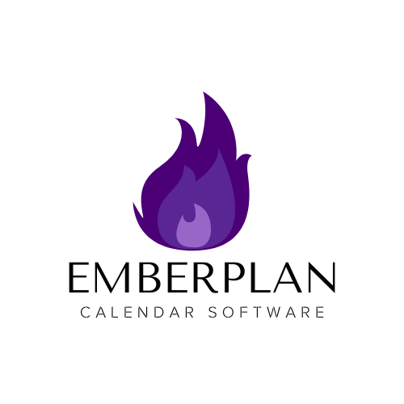

From Ember to Excellence – Become Your Best Self!

Austėja Tomaševskytė

Kamilė Balžekaitė

Maria Rodrigues

Rea Sklika

Spring 2025

Table of Contents

1. Introduction 2

1.1. Project Titles 3

1.2. Problem Statement 3

2. User Needs Analysis 3

2.1. Expectations of the Stakeholders 4

2.2. Primary Stakeholders 4

2.2.1. Current users’ activities 4

2.2.1.1. Timing 4

2.2.1.2. Forgetfulness 5

2.2.1.3. Lack of Motivation 5

2.2.1.4. Self-Doubt 6

2.2.1.5. Overwhelmingness 6

2.2.2. Characteristics of the People, Activities, Context, and Technologies 6

2.2.3. Needs 7

2.2.4. Usability Objectives 8

2.3. Secondary Stakeholders 8

2.3.1. Current users’ activities 8

2.3.1.1. Struggling with Employee Goal Tracking 8

2.3.1.2. Struggling with Student Goal Commitment 9

2.3.1.3. Struggling with Client Accountability 9

2.3.2. Characteristics of the People, Activities, Context, and Technologies 9

2.3.3. Needs 10

2.3.4. Usability Objectives 10

2.4. Inspiring User Interface Designs 11

2.4.1. Forgetfulness & Motivation 11

2.4.2. Motivation & Habit Consistency 12

2.4.3. Time Management & Goal Sharing 15

2.4.4. Structured Goal-Tracking & Feedback 16

2.4.5. Self-Doubt & Motivation 19

2.4.6. Overcoming Overwhelmingness 21

3. Alternative Wireframes 24

3.1 Implemented User Needs 24

3.2 Information Architecture Solutions 26

3.2.1. Ontology 26

3.2.2. Design Approaches 26

3.2.3. Structuring 26

3.2.4. Content Organization Schemes 26

3.2.5. Navigation Patterns 27

3.2.6. Labelling & Search Patterns 27

3.3 Used Prototyping Tools and Instructions for Evaluators 27

4. Usability Testing 28

4.1. Participants 28

4.2. Methodology 29

4.2.1. Testing goals 29

4.2.2. Testing environment 29

4.2.3. Testing session 29

4.2.4. Testing tasks with success criteria 30

4.3. Findings 31

4.3.1. Finding Achievements 31

4.3.2. Finding the Button 31

4.3.3. Adding an Event 32

4.3.4. Adding an Entry to a Goal 32

4.3.5. Finding the Profile 33

4.3.6. Finding a Friend (Emily) 33

4.3.7. Success Criteria 34

4.3.8. General Usability Feedback 35

4.4. Recommendations 35

4.4.1. Advantages of the considered mock-ups 35

4.4.2. Defects 36

4.4.3. Design solution for a more detailed prototype 36

4.5. Appendices 37

5. High-Fidelity Prototype 37

5.1. Final User Needs 37

5.2. Instructions For Evaluators 38

# Introduction

## Project Titles

Full Title: EmberPlan Calendar Software: From ember to excellence – become your best self!

Short Title: Calendar

## Problem Statement

One of the most positive things about the New Year is that it gives people a fresh start – a point from where they can turn their life around. Most of us set personal goals for the next year so that our dreams can become reality. Unfortunately, the willingness to put in the hard work and constantly push yourself to be better is not as easy to maintain, and therefore, a lot of people lose hope and give up half-way or even in the beginning of their journey.

There are a lot of difficulties in the process of keeping up with your New Year’s resolutions. In the beginning of the year, people tend to feel overwhelmed and do not know where to start or they have such busy schedules that it feels impossible to squeeze in any additional project. Some of them are also forgetful and need constant reminders to keep up with their goals. Most of us have the ambition to see our personal growth and accomplish the resolutions throughout the year, but the motivation to consistently push yourself forward can very easily be lost.

Almost everyone, regardless of age and gender, who creates New Year’s resolutions is affected by these problems previously mentioned. It does not matter in which area of your life you wish to improve – it can be anything from household chores, studying, healthy habits, performance in your job to learning new skills or taking up new hobbies – almost everything allows for individual growth. Therefore, every year, especially in January, people need to have a little bit of motivation to keep moving forward and accomplishing their goals.

Thus, having a plan for your next steps in digital form and seeing your progress (or perhaps your failures) could undoubtedly help people become the best version of themselves. It will not only enhance physical, but mental health as well and boost confidence and the sense of self-accomplishment. It could drastically improve the success of New Year’s resolutions and contribute to everyone’s overall happiness.

This highlights the need for strategies that help people stay engaged and accountable, making it easier to follow through on their resolutions and achieve personal growth.

# 2. User Needs Analysis

## 2.1. Expectations of the Stakeholders

* Primary stakeholders – the main primary stakeholders are anyone who sets up New Year’s resolutions and uses their mobile phones everyday – that means mostly younger generations, because the elderly are not used to mobile devices that much. Their expectation is an easy and intuitive app to use where they can see the progress of their goal, reminders for their tasks, and constant motivation for long-term commitment. The app must have enough functionality for a lot of different goals to track different forms of self-improvement tasks.
* Secondary stakeholders – it includes wellness and health professionals, gyms, educational institutions and employers of different companies in general. They are interested in using this app to reach out to broader audiences for their services. For some institutions (for example – schools, universities, employers and HR departments) it could be beneficial to use this inside the company for their own employees or students to boost their productivity. For other health professionals or gyms, the app could be the perfect platform to advertise their company or services.
* Indirect (tertiary) users, business owners, managers – they expect features that allow for tracking and analytics, enabling them to assess progress and provide motivation. It could be beneficial for them to receive statistics about people’s participation in sports, different healthy habits or the best time in the day when people perform certain activities. They may expect integration options to align the app with their own offerings, such as wellness programs, online courses, coaching services.
* Competitors – they expect that the product will be created legally and corresponding to economic and ethical laws. They also expect us to introduce new features to our application, this is, as new technologies and innovations arise, they would need to apply them as well.
* Development and maintenance team – they expect to have good and fair job conditions and feel valuable during this project. Additionally, they would hope for good communication inside their team and with a manager.

## 2.2. Primary Stakeholders

### 2.2.1. Current users’ activities

### 2.2.1.1. *Timing*

Description of Current Activity

Ana is a 22-year-old college student who is determined to get fit this year. She sets a resolution to go to the gym at least three times a week. She tries to schedule workout sessions between lectures, but her current calendar app lacks an intelligent scheduling feature. She has to manually check time slots and often miscalculates the duration needed for her responsibilities, which leads to her running late or skipping workouts due to miscalculations.

Problems and Opportunities

The main problem is that Ana struggles with time management between her gym routine and academic responsibilities. An opportunity exists to create an app feature that integrates with her calendar, allowing her to schedule gym sessions around her classes. That feature could suggest time slots based on existing commitments and add alerts for overlapping or tightly packed events. Additionally, the app could send her motivational messages to encourage her to stick to her gym plans despite her busy schedule. There could also be a feature that based on previous data about the duration of each activity Ana does, recommends realistic durations for tasks or even makes recommendations for gym sessions and reminds her when she is most likely to stick to the plan based on past behavior.

### 2.2.1.2. *Forgetfulness*

Description of Current Activity

Mark is a 30-year-old marketing manager who aims to cultivate a more organized lifestyle. He resolves to water his plants regularly. However, between work meetings and personal commitments, his current Reminders app only sends standard notifications, which he tends to ignore and lacks adaptive reminder that adjust based on his habits, leading to stressed or even dead plants.

Problems and Opportunities

The primary issue for Mark is forgetfulness and the lack of reminders for daily tasks. An opportunity exists to implement a customizable reminder system, that is smarter than his current one and adapts to user behavior, within the app that allows him to set alerts for watering plants. Gamifying these reminders, such as a streak system where Mark earns virtual badges or rewards for maintaining consistency, could motivate him to stay on track with his goals and create a sense of accomplishment. Persistent pop-ups, emails, voice reminders or a morning summary of the day’s schedule could all help users like Mark.

### 2.2.1.3. *Lack of Motivation*

Description of Current Activity

Olivia is a 36-year-old stay-at-home mother with two young children. She has a habit of smoking outside the house at least three times a day. However, she desperately wants to quit this habit for her own health and her children’s well-being. Olivia tried to quit smoking last year using some digital calendar apps. Those tools send her motivational messages, but Olivia keeps dismissing them. That way, she quickly lost motivation and went back to her old habits.

Problems and Opportunities

Olivia’s main issue is lack of personalized motivation and external support. There is an opportunity to create a progress tracking system for quitting bad habits inside the calendar. The app could send daily motivational messages and give gamified rewards for every successful period of time without doing that harmful habit. It is also possible to enable integration with social accountability features, like sharing her progress with friends.

### 2.2.1.4. *Self-Doubt*

Description of Current Activity

Neil, a 17-year-old student, decides to take on a new challenge, learning to play the guitar. He chooses to teach himself using tutorial videos, books, and apps like *Yousician*, without informing his friends or family. Initially, he makes steady progress, learning a few chords and songs. However, as the lessons become more difficult and without external feedback, Neil starts doubting his abilities, unsure if he is learning efficiently. Lacking reassurance and motivation, he eventually gives up.

Problems and Opportunities

Neil’s primary obstacle is self-doubt, without validation from others, he struggles to recognize his own progress. A calendar-based system that allows him to track milestones, document his improvement (e.g., recordings, practice logs), and optionally share updates with others could help reinforce his confidence. It could allow Neil to set skill level-based reminders and provide check ins where he reflects on his progress. By visually showcasing his growth, the system would provide a sense of achievement and sustained motivation, ultimately reducing self-doubt.

### 2.2.1.5. *Overwhelmingness*

Description of Current Activity

Abbie, a 38-year-old manager, uses her calendar to track meetings, deadlines and personal commitments. Her calendar is cluttered with overlapping events, making it hard to focus on priorities. The current calendar Abbie uses, has no prioritization or color coding to highlight the importance of each task and it lacks a decluttered mode to see only the most important tasks. The visual overload makes her feel stressed and she avoids looking at her calendar altogether, leading to last minute rushes.

Problems and Opportunities

Abbie’s main problem is the chaotic environment that currently exists in her calendar, she often misses important tasks because they are lost in a sea of minor appointments, making her feel overwhelmed. Introducing a “focus mode” that hides non- essential events during high stress periods would lessen the feeling of overwhelmingness. Additionally, customizable color-coded priorities and different color pallets for different event types could help the user feel more confident about the scheduled tasks.

### 2.2.2. Characteristics of the People, Activities, Context, and Technologies

The people who will use EmberPlan vary in age, background, and lifestyle, but they all share a common goal, maintaining their New Year's resolutions. Users include students managing busy schedules, professionals balancing work and personal commitments, individuals overcoming self-doubt or lack of motivation, and those navigating cluttered schedules. Their needs range from better time management (students, professionals), habit tracking (individuals overcoming self-doubt), external motivation (those who lack it) and structured guidance (users with overwhelming schedules). While some users prefer individual goal setting, others benefit from social support, reminders and interactive progress tracking.

The activities supported by the app involve managing time, planning, tracking, keeping up and achieving goals across different domains, such as fitness, organization, personal development, learning and being as efficient as possible. Users require a system that integrates seamlessly into their daily routines, helping them structure their tasks, set reminders and visualize progress to enhance efficiency and productivity. They vary in frequency (daily to monthly), duration (quick checks to in-depth planning) and complexity (simple tasks to managing overlapping commitments).

The context in which these activities occur varies, some users engage with the app in a structured work or study environment, while others use it in unpredictable, on-the-go situations. This means the app must be highly flexible, with features that adapt to shifting schedules and unexpected changes. Additionally, since users have multiple responsibilities (work, studies, family) they need a calendar app that integrates smoothly into their routine. People using this kind of software often feel stressed due to information overload, so the app must provide clear visual organization, prioritization tools and decluttering options.

The technologies involved include smart reminders and notifications that are personalized to each user needs and include persistent pop-ups, emails and daily summaries. Gamification and habit tracking both motivate users by incorporating streaks, social accountability and real-world connections. A simple colour coded pallet and focus mode will allow users to organise and filter their events the best way that works for them, offering better clarity. Furthermore, features using AI will help users organise their time effectively and achieve their goals providing personalized suggestions based on their past habits and commitments. Lastly, the app will sync with external platforms, such as fitness apps and learning tools for different skills, to provide a fully integrated productivity experience.

### 2.2.3. Needs

N1. Users need a feature that estimates realistic durations for tasks based on past patterns to avoid miscalculations. (2.2.1.1 Timing)

N2. Users with cluttered schedules need a decluttered calendar view to highlight important tasks and prevent feeling overwhelmed. (2.2.1.5 Overwhelmingness)

N3. Users need habit-based reminders that track consistency and notify them when they miss a task. (2.2.1.2 Forgetfulness and 2.2.1.3 Lack of Motivation)

N4. Users who frequently dismiss notifications need alternative reminder methods. (2.2.1.2 Forgetfulness and 2.2.1.3 Lack of Motivation)

N5. Users need a progress tracking feature that visually showcases their achievements over time. (2.2.1.3 Lack of Motivation and 2.2.1.4 Self-Doubt)

N6. Users need colour coded priorities to visually differentiate between critical and low-priority tasks. (2.2.1.5 Overwhelmingness)

### 2.2.4. Usability Objectives

1. Task Time: First time users will be able to schedule an event or habit in under 2 minutes without any prior guidance. Returning users will be able to set a reminder or adjust a scheduled task in less than 30 seconds.

2. Number of Errors: Users will successfully schedule events and habits without accidental duplication or conflicts at least 98% of the time.

3. Accomplished Tasks: At least 75% of users who set habit-tracking goals will log their progress at least three times per week. At least 80% of users will complete at least one scheduled task per day.

4. Revisits: At least 60% of users will return to the app at least four times per week to check their schedule, progress or reminder. At least 70% of users who enable motivational features (e.g. streaks) will continue using them after one month.

## 2.3. Secondary Stakeholders

### 2.3.1. Current users’ activities

### 2.3.1.1. *Struggling with Employee Goal Tracking*

Description of Current Activity

Lisa is a 40-year-old HR manager at a mid-sized tech company. Every year, she encourages employees to set professional and personal development goals. She currently uses Google Sheets app to track progress. However, employees rarely update their goals, and engagement drops within weeks.

Problems and Opportunities

The main problems are that task management apps are too generic and not tailored for long-term goal tracking, employees forget to check spreadsheets, making progress tracking ineffective. An opportunity exists to create a goal-setting app with automated reminders, gamification, and progress tracking that integrates with the company’s workflow. This would improve employee engagement and accountability.

### 2.3.1.2. *Struggling with Student Goal Commitment*

Description of Current Activity

Sarah is a 45-year-old psychology professor who encourages students to set academic growth goals step by step. She currently uses a popular study planner Notion Calendar app to help students track their progress and mark their tasks/homework. However, students complain that the app is too rigid and doesn’t account for long-term motivation.

Problems and Opportunities

The main problems are that current study planners focus only on deadlines and not habit-building. Students also tend to forget to log their progress, leading to inconsistent app usage. Therefore, an opportunity exists for a collaborative feature for peer motivation, habit tracking and instructor feedback tools, which would help with long-term commitment.

### 2.3.1.3. Struggling with Client Accountability

Description of Current Activity

Emily is a 38-year-old life coach who helps clients with personal growth and self-discipline. She has encouraged her clients to use a to-do list app called To Do to track their progress, but they rarely stick to it.

Problems and Opportunities

The main problems of the current app are that it doesn’t encourage reflection on long-term goals, making clients feel no sense of accomplishment beyond checking off tasks. To add more, it lacks communication tools for coaches to track and encourage client progress. An opportunity exists for a feature to report progress, track habits and to have tools for client-coach interaction, improving retention and results.

### 2.3.2. Characteristics of the People, Activities, Context, and Technologies

People:

Secondary stakeholders include HR managers, professors and life coaches. They are professionals looking for ways to enhance productivity, engagement, and goal achievement within their teams, students, or clients. Most have experience using digital tools but find existing options ineffective for long-term motivation.

Activities:

These stakeholders need to track progress, motivate users, and maintain engagement over time. They often work with groups (employees, students, clients) and require a way to monitor multiple people’s progress efficiently.

Context:

The app would be used in workplaces, education settings, coaching environments. Users may interact with it during meetings, check-ins, or on-the-go, making accessibility and ease of use crucial.

Technologies:

Stakeholders currently rely on spreadsheets, task management apps, study planners and communication platforms. The app should integrate with existing digital tools and be available across multiple devices.

### 2.3.3. Needs

N1. Lisa needs a gamified goal-tracking system that integrates with workplace tools to encourage regular employee updates. (2.3.1.1 Struggling with Employee Goal Tracking)

N2. HR managers need a feature that sends single reminders to employees about their goals to increase engagement. *(2.3.1.1 Struggling with Employee Goal Tracking)*

N3. Sarah needs a habit-building feature that supports long-term academic goals rather than just focusing on deadlines. *(2.3.1.2 Struggling with Student Goal Commitment)*

N4. Professors need a way to communicate, provide feedback and track student commitment over time, rather than just monitoring task completion. *(2.3.1.2 Struggling with Student Goal Commitment)*

N5. Emily needs an app that encourages clients to write reflections on long-term progress, not just check off tasks. *(2.3.1.3 Struggling with Client Accountability)*

N6. Life coaches need an integrated client progress tracking tool that allows communication and feedback within the app. *(2.3.1.3 Struggling with Client Accountability)*

N7. All secondary stakeholders need a dashboard that visually presents user progress and engagement metrics. *(2.3.1.1, 2.3.1.2, 2.3.1.3)*

N8. Users need goal customization options so HR managers, professors, and life coaches can set up relevant challenges. *(2.3.1.1, 2.3.1.2, 2.3.1.3)*

N9. The app should support integration with tools like Google Calendar, Notion, and Slack to fit into existing workflows. *(2.3.1.1, 2.3.1.2, 2.3.1.3)*

### 2.3.4. Usability Objectives

1) Goal Setup Efficiency: Secondary stakeholders should be able to create and assign a goal to their employees, students, or clients in under 3 minutes.

2) Reminder Effectiveness: At least 60% of users can respond to automated reminders within one hour of receiving them.

3) Progress Tracking: HR managers, professors, and coaches should be able to view a participant’s progress and engagement level within 30 seconds.

4) Seamless Integration: At least 80% of stakeholders should successfully connect the app with an external tool (Google Calendar, Notion, Slack) within the first week of use.

## 2.4. Inspiring User Interface Designs

### 2.4.1. Forgetfulness & Motivation

Streaks – Streaks helps users maintain daily habits through a streak-based tracking system, where each completed task extends the user’s streak, reinforcing habit consistency. The app supports both daily and recurring tasks, allowing flexibility in habit-building. Users receive customizable reminders, ensuring they stay on track with their commitments. Streaks is designed to work across a wide range of devices, offering seamless synchronization between Apple devices, including iPhone, iPad, Apple Watch, and Mac (*Image 1*).

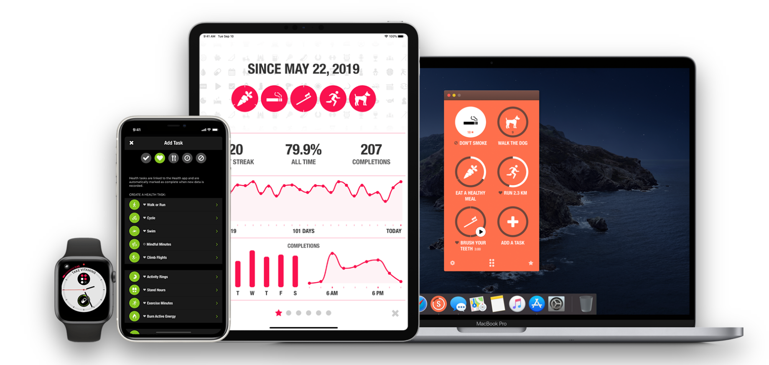

*Image 1*: Streaks UX. Shows the different pages for creation and tracking of tasks, across different devices.

Source: [STREAKS. The to-do list that helps you form good habits. For iOS.](https://streaksapp.com/)

Notion – Notion is a powerful organization and productivity tool that enables users to create customizable databases, checklists, and habit-tracking templates. It provides a flexible workspace where users can track goals, organize tasks, and set reminders, making it ideal for those who struggle with forgetfulness (*Image 2*)*.* Notion’s integration with calendars, Kanban boards, and collaborative features allows for structured planning *(Image 3*)*.* Its cross-platform availability (desktop, mobile, and web) ensures accessibility across different devices.

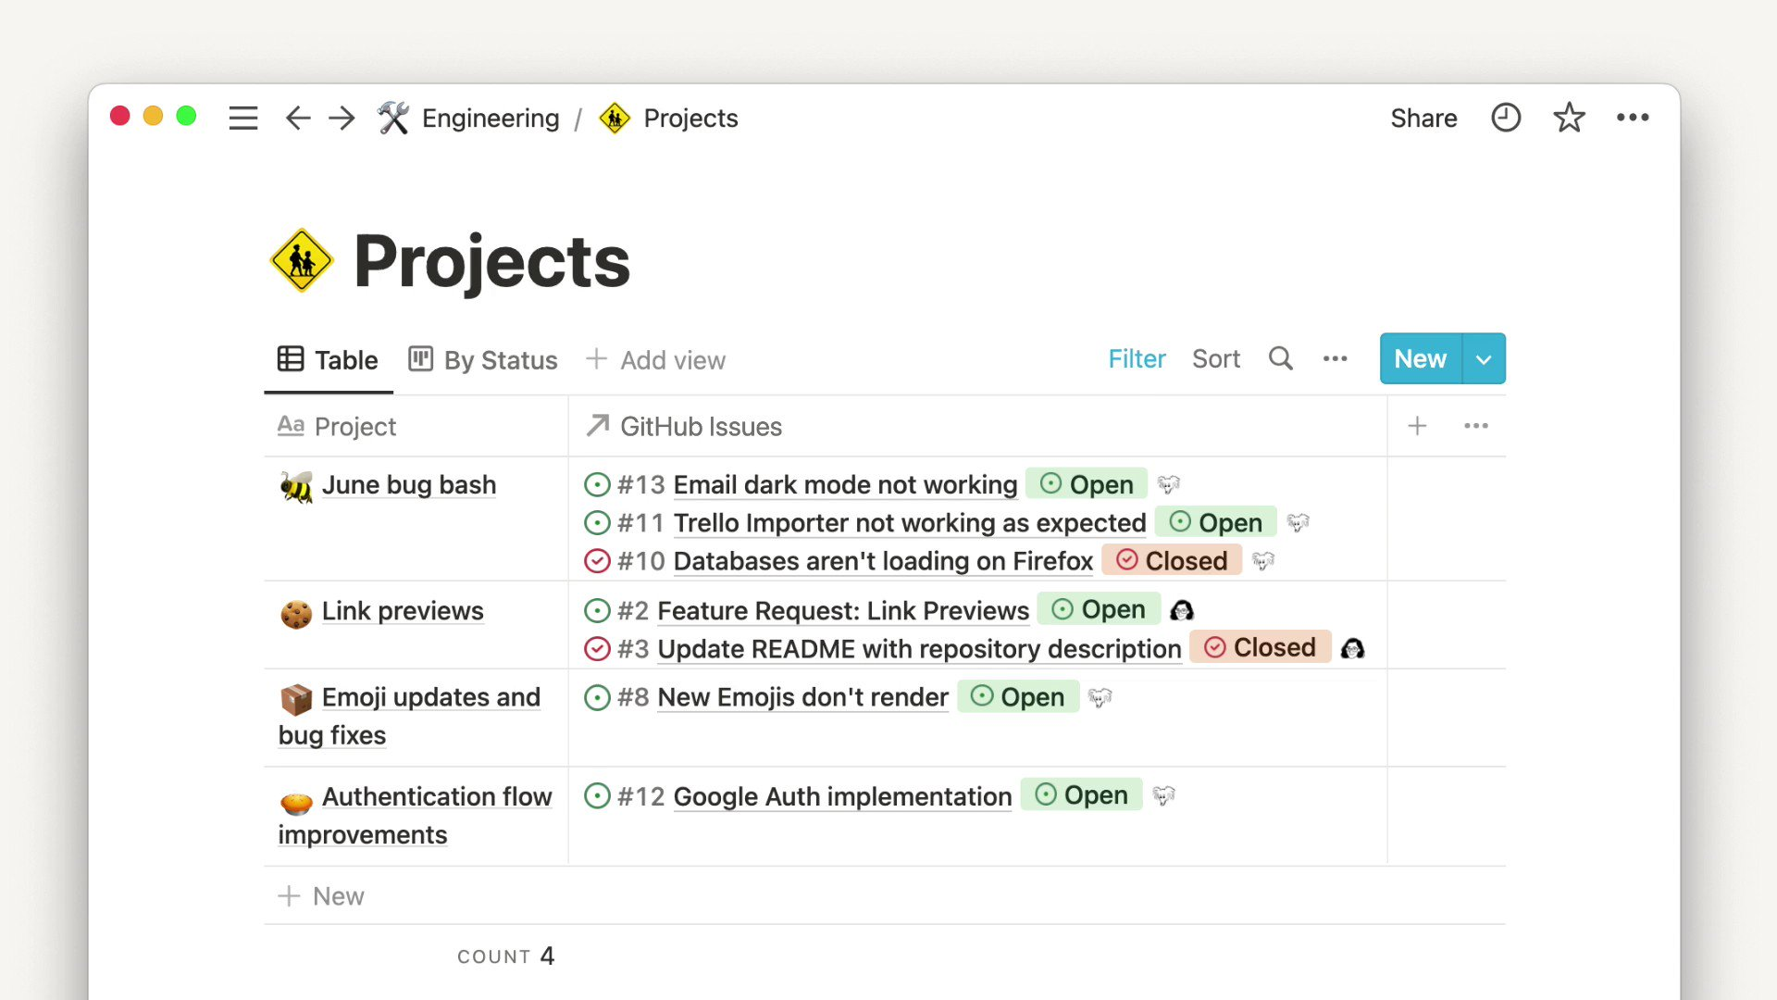

*Image 2*: Notion UX. Has folder with different projects, and the task that must be completed inside it.

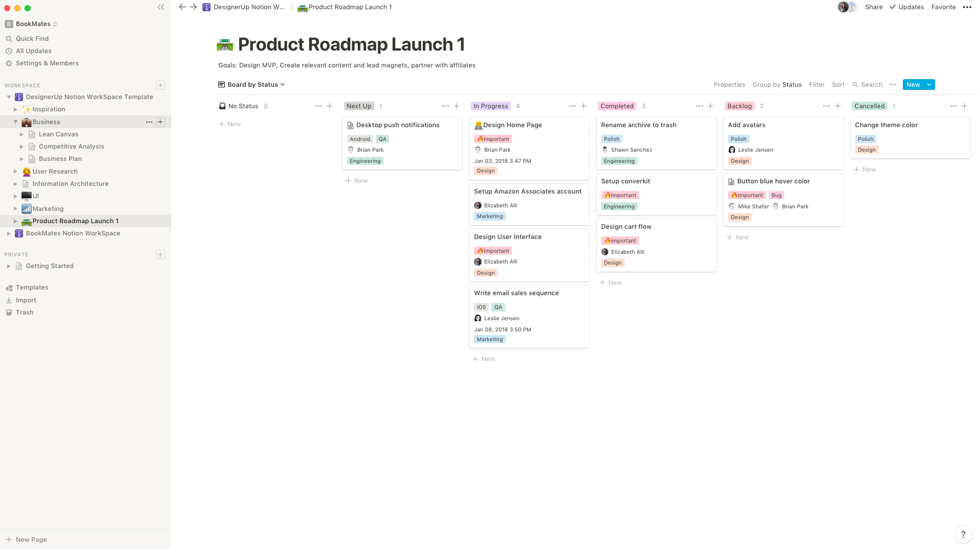

*Image 3*: Notion UX. Shows the label each task is assigned at the moment (e.g. In Progress, Cancelled)

Source: [Notion Desktop App for Mac & Windows | Notion](https://www.notion.com/desktop)

From the user need and usability objectives, we can point out 2.2.1.2. and 2.3.1.1. respectively. In this case, we look into the user stories of Sarah, a professor who needs a system that helps students stay committed to their academic goals by reminding them of their tasks, and Olivia, who wants an app to provide motivational reminders to help her stay committed to quitting smoking.

### 2.4.2. Motivation & Habit Consistency

Forest – Forest is a habit-tracking and focus app that uses gamification to encourage productivity. When users start a task, they plant a virtual tree, which grows over time as they stay focused *(Image 4*)*.* If they leave the app before completing the task, the tree dies, reinforcing habit discipline. Over time, users build an entire “forest” of completed tasks, providing a visual representation of their progress *(Image 5*). Additionally, the app also integrates with real-world tree planting initiatives, adding an eco-friendly motivation aspect.

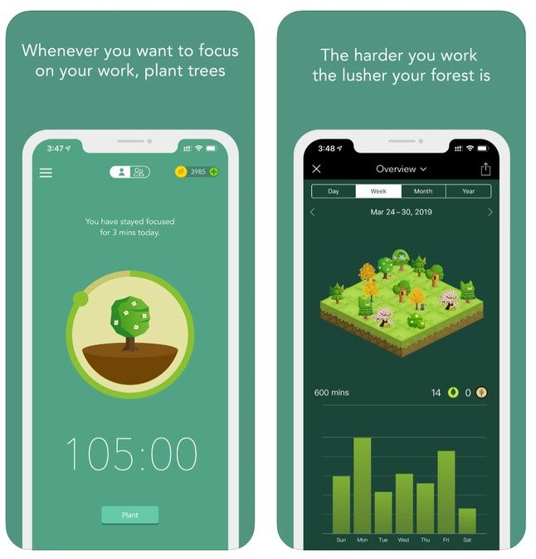

*Image 4*: Forest UX on phone. Shows the growing of a tree from the task the user is focusing on (left); the user’s forest and a graph with the user’s focus minutes per weekday (right).

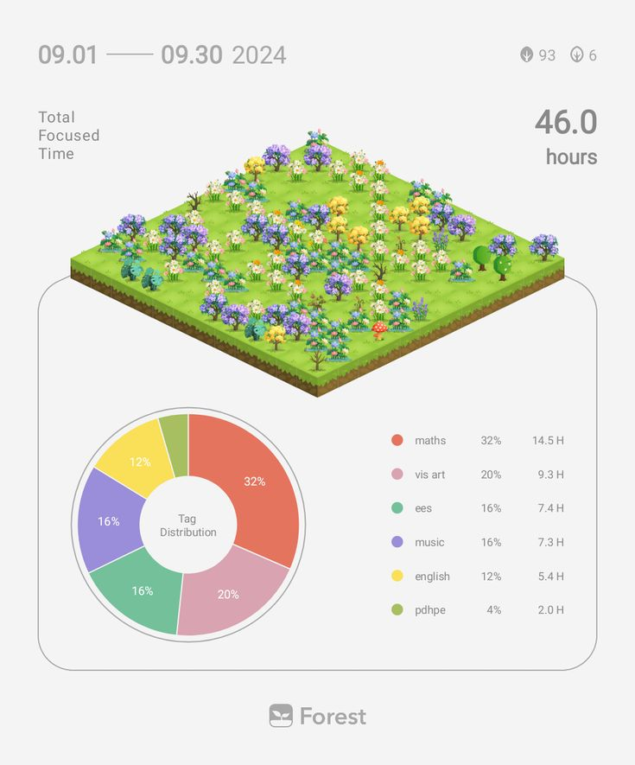

*Image 5*: Forest UX. Shows a user’s forest, as well as the time spend on each task.

Source: [Forest - Stay focused, be present](https://www.forestapp.cc/)

Shine – Shine is a self-care and wellness app that provides daily motivational messages, self-care tips, and guided meditations. It is designed to help users develop a positive mindset and maintain motivation when working toward personal goals. Shine offers a personalized experience, adapting its content to users' emotional well-being and progress. The app includes journaling prompts, mindfulness exercises, and affirmation notifications to keep users engaged *(Image 6*).

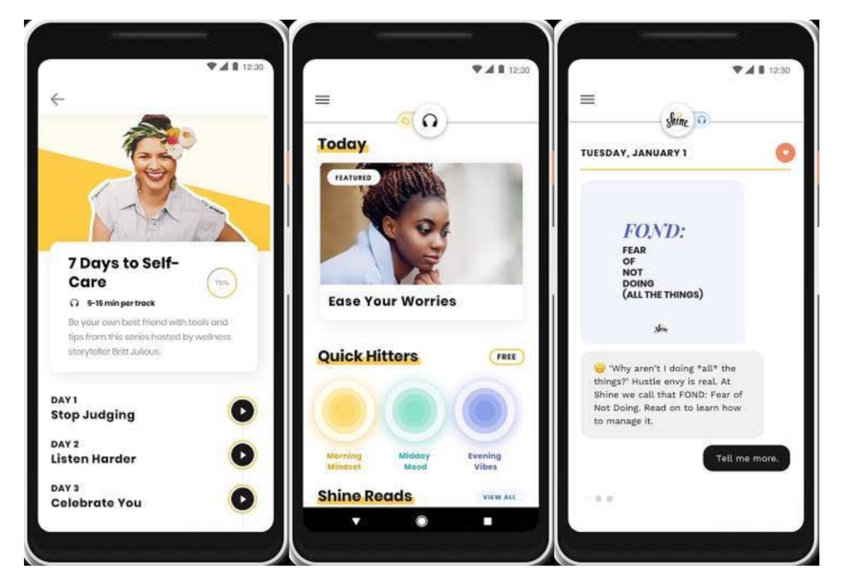

*Image 6*: Shine UX. Shows daily “podcasts” for mental self-care, main page, and personal chat with motivational quotes.

Source: [Get Advice | Shine](https://advice.theshineapp.com/)

We can identify 2.2.1.3. and 2.3.1.2., respectively, based on the user need and usability objectives. In this instance, we examine the user stories of Olivia, who need motivation and habit-tracking tools to help her stop smoking, and Lisa, an HR manager who wants staff members to remain committed to their long-term objectives. Both users need a system that uses reminders, gamification, and progress tracking to reinforce consistency.

### 2.4.3. Time Management & Goal Sharing

TimeTree – TimeTree is a collaborative calendar app that allows users to organize their schedules, share events, and track plans with color-coded categories. It supports multiple calendars, making it easy to separate personal, work, and shared commitments (*Image 8*). The color-coding system helps users visually distinguish between different types of goals, reducing scheduling confusion (*Image 7*). TimeTree enables event-sharing with friends, family, or colleagues, making it ideal for group goal tracking or accountability partnerships.

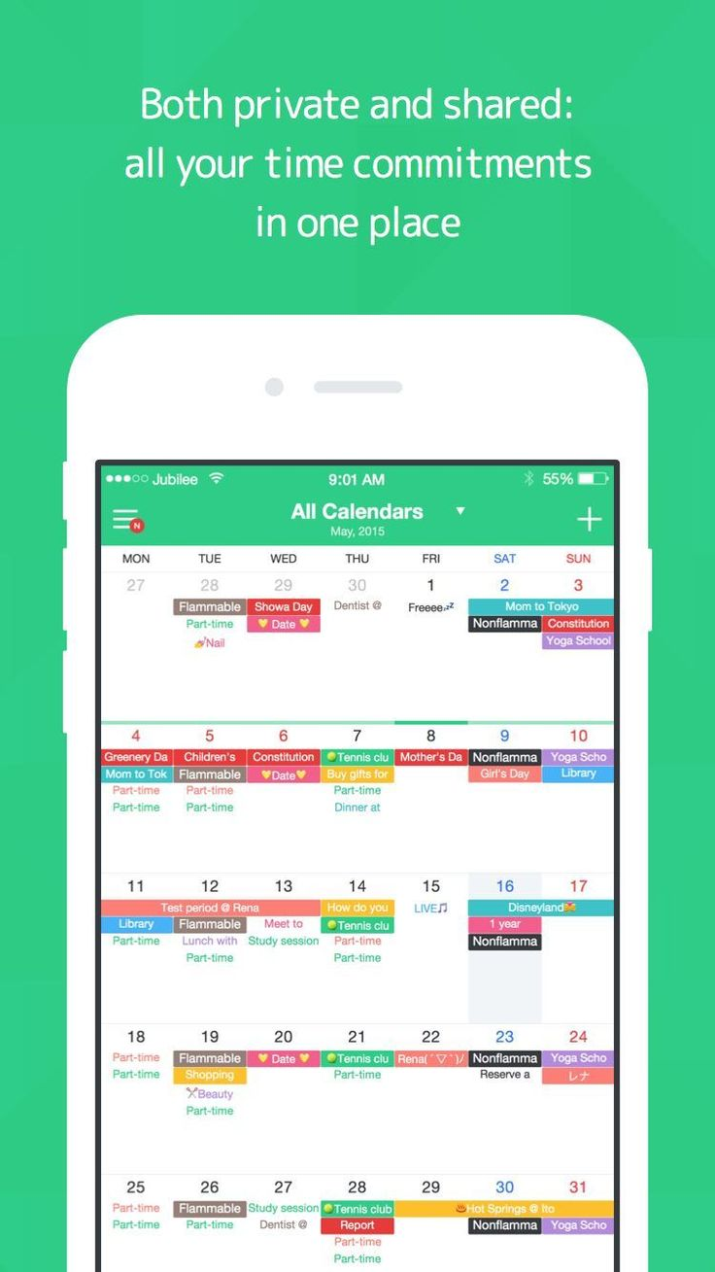 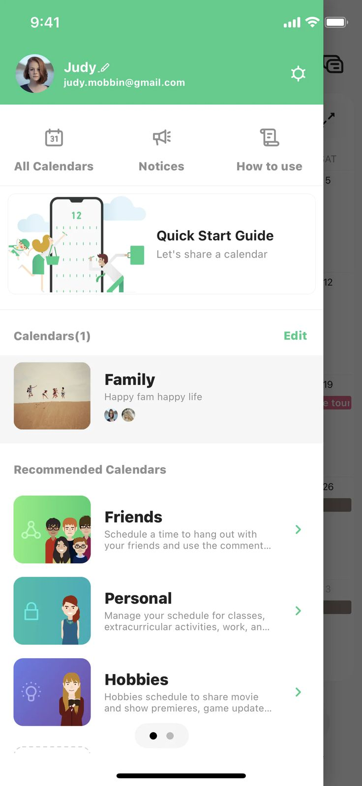

*Image 7* (left): TimeTree UX, showacsing calendar view, where users can organize tasks and goals using colour-coded categories.

*Image 8* (right): TimeTree UX, showing the various calendars for each user, which can be shared.

Source: [TimeTree | An app for easy calendar sharing and communication](https://timetreeapp.com/intl/en)

Google Calendar – Google Calendar is a widely used scheduling tool that allows users to create events, set reminders, and synchronize across multiple devices. Its integration with Google services (Gmail, Google Tasks, and Google Assistant) enhances productivity by automatically detecting events from emails or voice commands. Google Calendar also supports color-coded event categorization, helping users visually organize different aspects of their lives, whether work, health, or personal goals (*Image 9*).

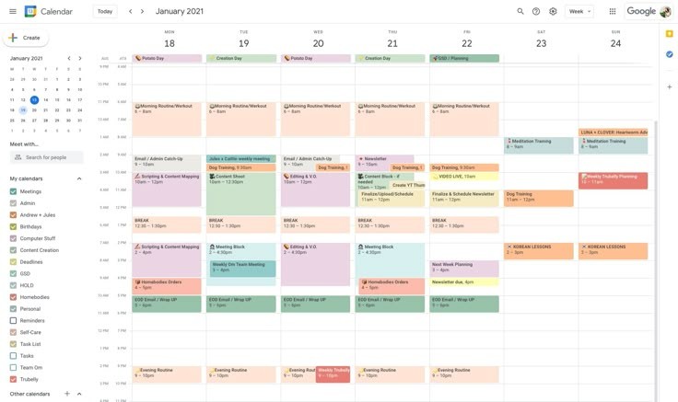

*Image 9*: Google Calendar UX. Shows weekly view of an organized schedule, which colour coded tasks by category, which are represented in time blocks (overlapping).

Source: [Google Calendar](https://calendar.google.com/calendar/)

From the user need and usability objectives, we can point out 2.2.1.1. and 2.3.2.1. respectively. In this case, we look into the user story of Ana, a college student with a busy schedule. She wants to organize her tasks into a clear timeline and have an intelligent scheduling system that helps her find time for the gym.

### 2.4.4. Structured Goal-Tracking & Feedback

Nike Training Club – Nike Training Club is a fitness app offering structured workout programs, goal tracking, and personalized training recommendations (*Image 10*). It features a wide range of workout categories, including strength, endurance, mobility, and yoga. The app provides real-time feedback, helping users adjust their techniques and improve their fitness journey. Nike Training Club adapts workouts based on progress, ensuring that users stay challenged but not overwhelmed.

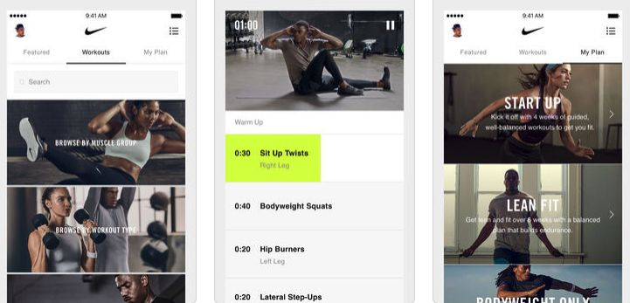

*Image 10*: Nike Training Club UX. Has the option to search through possible workouts, has timed exercise, and personal training plans.

Source: [Nike Training Club App. Home Workouts & More. Nike IN](https://www.nike.com/in/ntc-app?msockid=2f56aca678086d532822b9e4796f6c01)

Duolingo – Duolingo is a language-learning app that uses streak-based progress tracking (*Image 12*), milestone rewards, and gamification to keep users engaged. The app features short, interactive lessons, instant feedback on mistakes, and personalized learning paths (*Image 11*). Duolingo’s leaderboards and achievement badges add a social motivation element, encouraging users to stay consistent (*Image 13*).

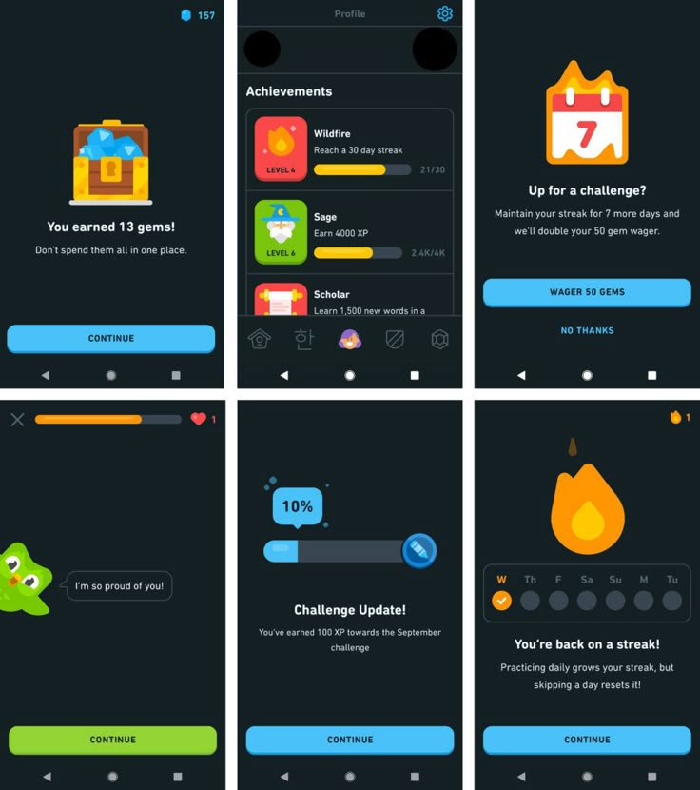

*Image 11*: Duolingo Lessons’ UX. Shows rewards, achievements, challenges, motivational quotes, progress tracking and weekly streak.

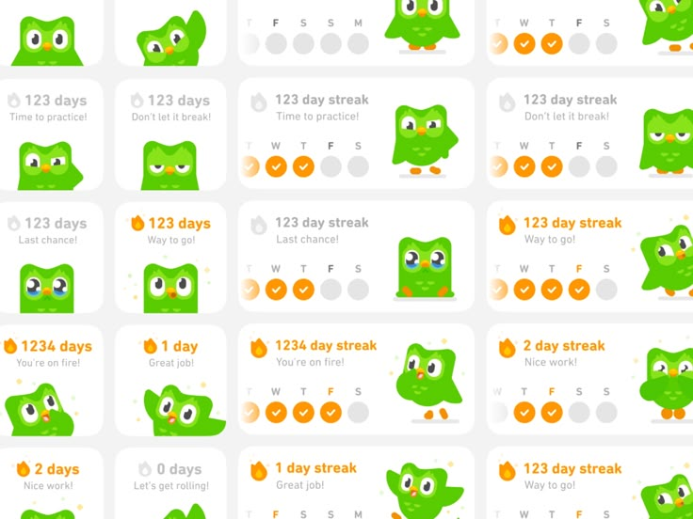 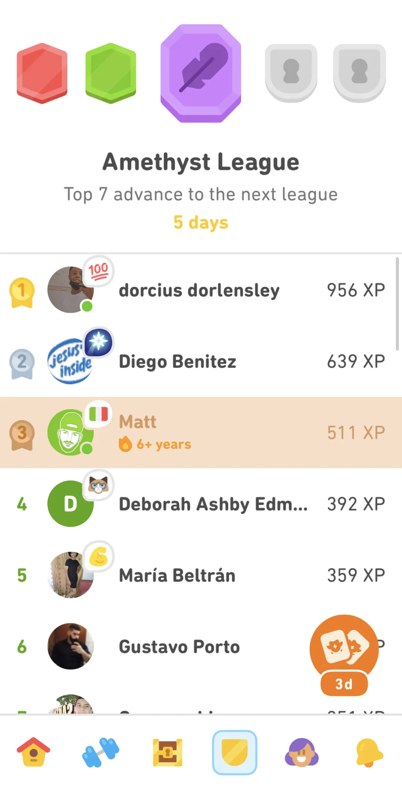

*Image 12* (left): Duolingo Streak Widget UX.

*Image 13* (right): Duolingo UX for the leaderboard.

Source: [Duolingo - The world's best way to learn a language](https://www.duolingo.com/)

Yousician – Yousician is a music-learning app that provides real-time feedback on playing instruments such as guitar, piano, and bass. It listens to users' playing and offers instant corrections to help them improve (*Image 14*). The app includes structured lessons, progress tracking, and gamification elements, making learning engaging and reinforcing consistency.

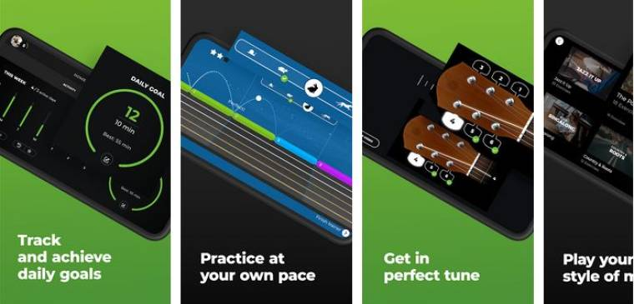

*Image 14*: Yousician UX. Shows different characteristics the software offers.

Source: [Learn music the easy way | Yousician](https://yousician.com/lp/yousician?msclkid=5da2e51c7d861e83fb9f82da833dfece&utm_source=bing&utm_medium=cpc&utm_campaign=Yousician%20-%20Brand%20Name%20-%20WW&utm_term=yousician&utm_content=Brand%20-%20EN%20(PH))

We can identify 2.2.1.5 and 2.3.3.1 based on the usability goals and user needs, respectively. Here, we examine the user stories of Mark, a professional who requires systematic goal-setting and progress tracking for personal organisation, and Sarah, a professor who encourages students to monitor their academic progress. Both require a system that offers feedback mechanisms, quantifiable progress indicators, and organised tracking.

### 2.4.5. Self-Doubt & Motivation

Headspace – Headspace is a mindfulness and meditation app that supports users in developing better mental well-being, focus, and confidence. It features guided meditation sessions, sleep aids, breathing exercises, and mindful habit coaching (*Image 15*). The app also includes daily motivational messages and affirmations to help users overcome self-doubt and stress.

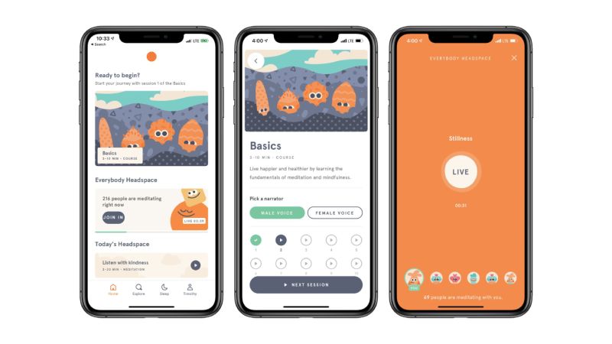

*Image 15*: Headspace UX. Different stages when starting using the app for doing a guided meditation session.

Source: [Meditation and Sleep Made Simple - Headspace](https://www.headspace.com/)

Apple Journal – Apple Journal is a digital journaling app designed to help users reflect on their personal progress, track emotions, and stay motivated. It integrates rich media (photos, voice notes, and location data) to provide a personalized journaling experience. By encouraging users to document their journey, Journal helps reinforce self-awareness, confidence, and long-term motivation.

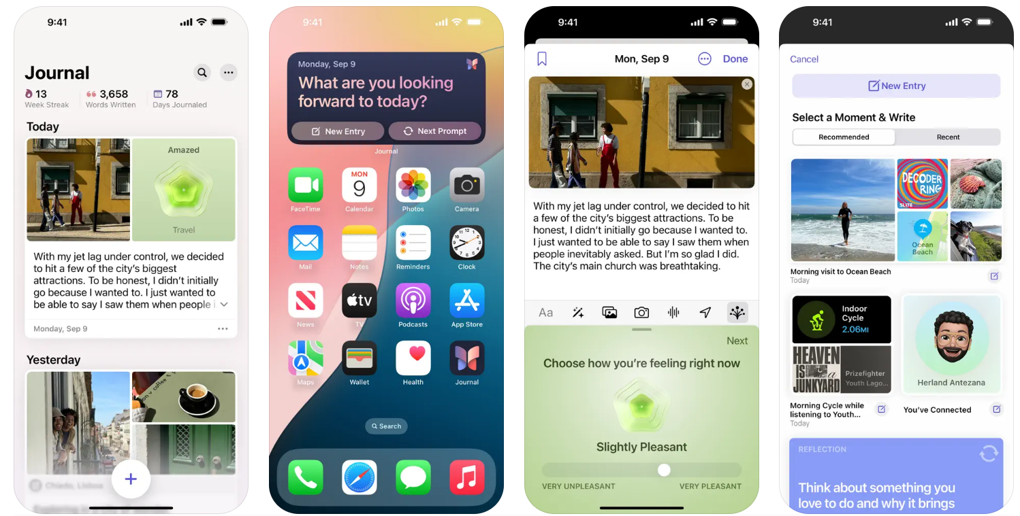

*Image 16*: Apple Journal UX. Shows the journal entries, motivational quote as widget, asks for the mood the user is in and suggests moments for the user to write what he/she was feeling, respectively.

Source: [Apple launches Journal app, a new app for reflecting on everyday moments - Apple](https://www.apple.com/newsroom/2023/12/apple-launches-journal-app-a-new-app-for-reflecting-on-everyday-moments/)

We can identify 2.2.1.4 and 2.3.4.1 based on the user need and usability objectives, respectively. In this instance, we examine Neil's user story, a guitar student who battles self-doubt. To boost his confidence in his educational journey, he wants an app that tracks his milestones and visualises his progress.

### 2.4.6. Overcoming Overwhelmingness

Miro – Miro is a digital whiteboard tool that supports sticky notes (*Image 17*), mind mapping (*Image 18*), and collaborative brainstorming. It helps users break down large projects or goals into smaller, manageable steps. The tool is widely used for visual organization, making it ideal for users who feel overwhelmed when starting a complex goal.

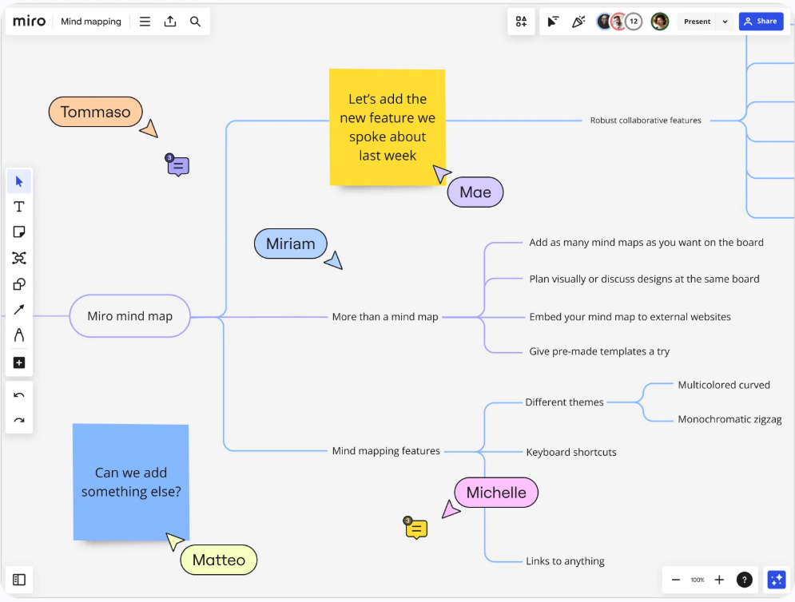

*Image 17*: Miro Mind Map UX. Shows how to break down a complex problem with ease in the form of a mind map.

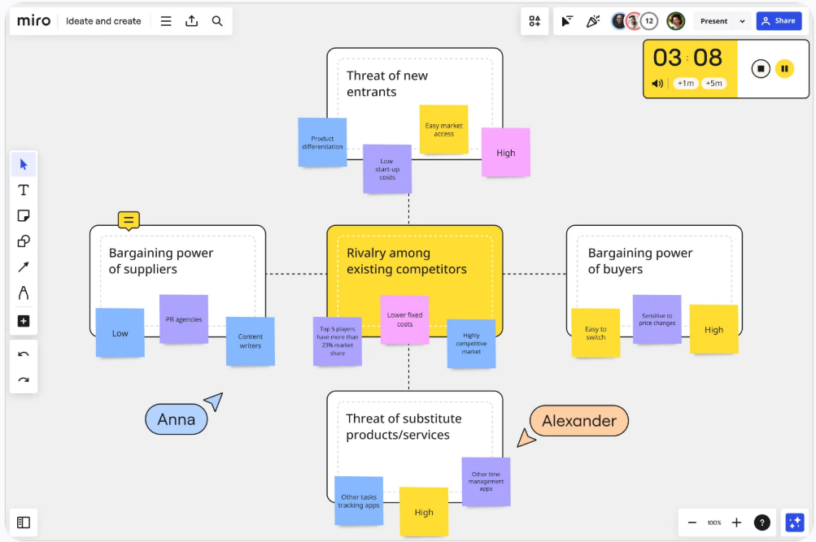

*Image 18*: Miro sticky notes UX. Shows an example of brainstorming ideas and solutions in the form of a white board with sticky notes, which can be shared with other coworkers.

Source: [Miro | The Innovation Workspace](https://miro.com/)

Skillshare/Coursera – Skillshare and Coursera provide structured learning paths for users transitioning into new careers or skill sets. These platforms break down complex topics into guided courses, offering step-by-step learning (*Image 20*). Coursera provides certification programs for professional growth (*Image 21-23*), while Skillshare focuses on creative and hands-on skills (*Image 19*).

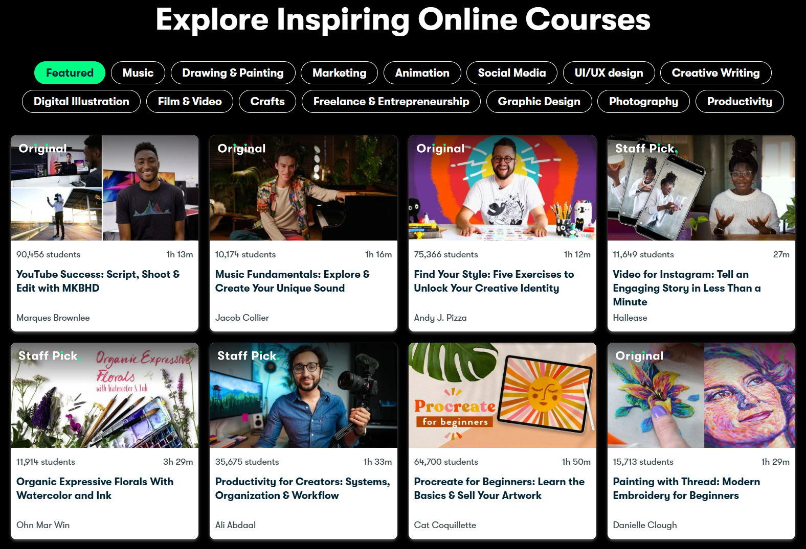

*Image 19*: Skillshare UX for choosing online courses.

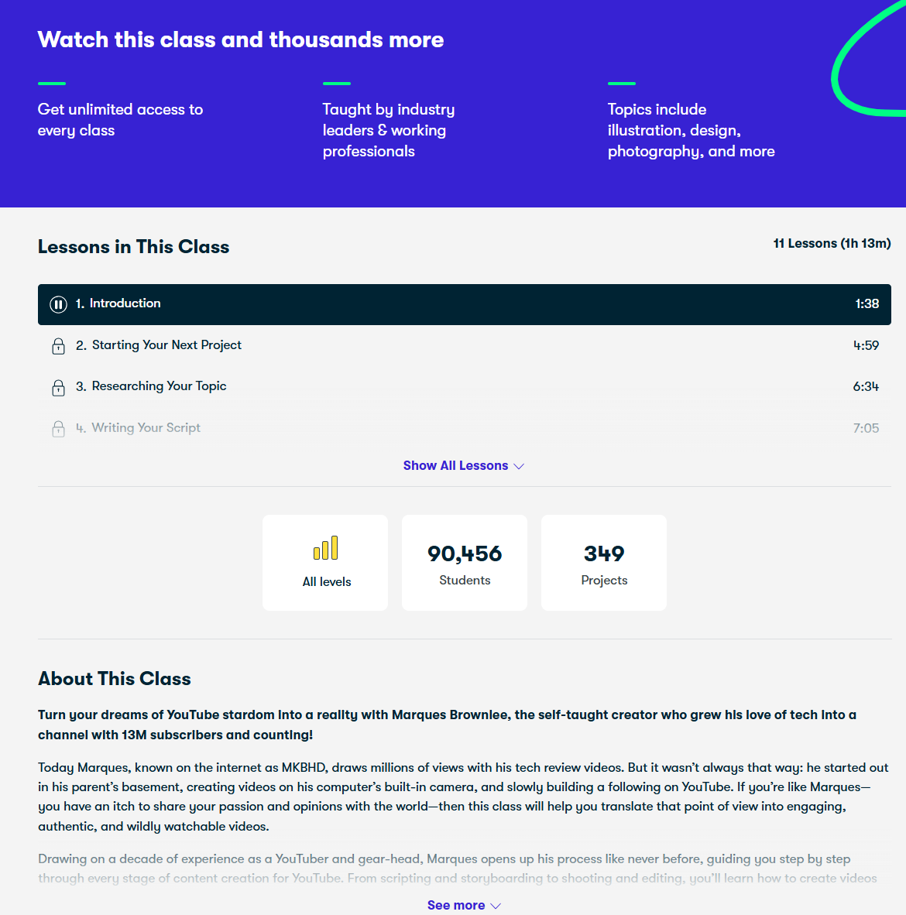

*Image 20*: Skillshare Online Class UX. Additional information on an online course, how the lessons are structured, and the number on students enrolled in it.

Source: [Online Classes for Creatives | Skillshare](https://www.skillshare.com/en/)

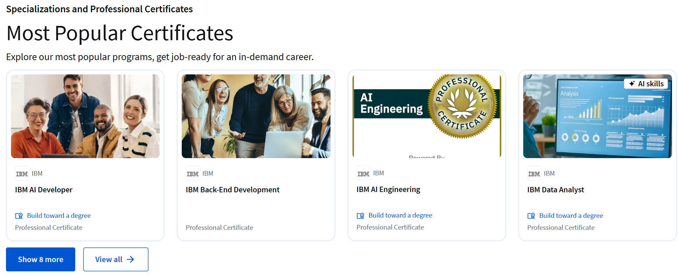

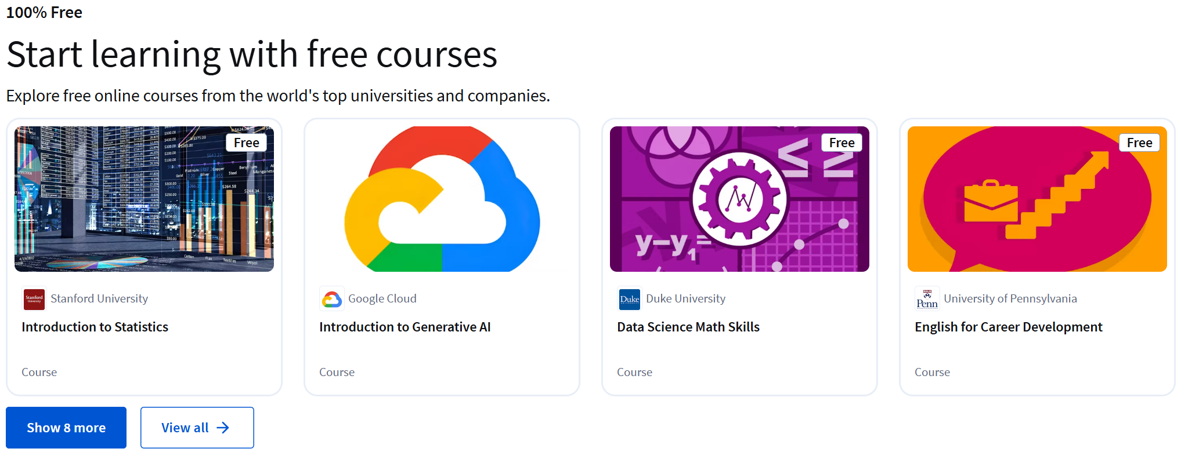

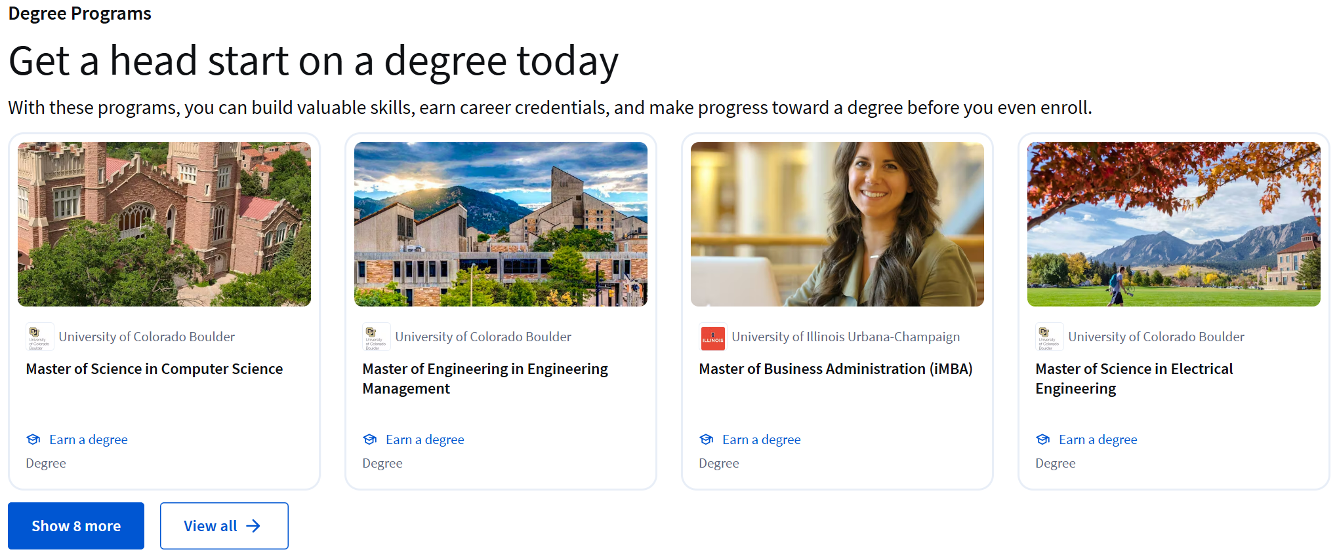

*Image 21-23*: Coursera UX for taking courses. From first to last, for the most popular certificates (*21*), free courses (*22*), and courses that will complement a degree in higher education (*23*).

Source: [Coursera | Degrees, Certificates, & Free Online Courses](https://www.coursera.org/)

From the user need and usability objectives, we can point out 2.2.1.6. and 2.3.5.1. respectively. In this case, we look into the user story of Abbie, a professional who feels overwhelmed by large tasks. She wants the app to help her prioritize tasks, declutter her schedule, and break goals into manageable steps.

# 3. Alternative Wireframes

## 3.1 Implemented User Needs

* **N1**. Lisa needs a goal-tracking system that integrates with workplace tools and provides automated reminders to encourage employee engagement. *(2.3.1.1 Struggling with Employee Goal Tracking)*  
  **Solution**: IA includes a dashboard-style progress overview and gamification features to increase motivation. The chosen rapid prototyping tool (Figma) enables testing of these interactive elements.
* **N2**. HR managers need a feature that allows them to monitor employee engagement and track goal progress in real-time. *(2.3.1.1 Struggling with Employee Goal Tracking)*  
  **Solution**: IA includes real-time progress tracking with a filterable leaderboard, providing an overview of employee commitment.
* **N3**. Sarah needs a habit-tracking feature that encourages students to stay consistent with academic goals beyond deadlines. *(2.3.1.2 Struggling with Student Goal Commitment)*  
  **Solution**: IA incorporates habit-building structures, such as streaks and gamified learning milestones, to reinforce motivation.
* **N4**. Professors need a way to provide structured feedback to students and track their long-term progress. *(2.3.1.2 Struggling with Student Goal Commitment)*  
  **Solution**: IA includes instructor feedback tools integrated into the student dashboard, allowing professors to track engagement and provide insights.
* **N5**. Emily needs an app that encourages clients to reflect on their long-term progress rather than just checking off tasks. *(2.3.1.3 Struggling with Client Accountability)*  
  **Solution**: IA supports journaling features and progress visualization, allowing clients to log reflections and track habit improvements over time.
* **N6**. Life coaches need an integrated communication tool that allows for direct interaction with clients inside the app. *(2.3.1.3 Struggling with Client Accountability)*  
  **Solution**: IA includes client-coach interaction tools, such as progress reports and messaging, enabling coaches to give real-time feedback.
* **N7**. All secondary stakeholders need a centralized dashboard to visualize user engagement, goal completion, and progress analytics. *(2.3.1.1, 2.3.1.2, 2.3.1.3)*  
  **Solution**: IA incorporates a data-driven progress dashboard that allows tracking of individual and group performance in real-time.
* **N8**. Users need customizable goal-setting options so HR managers, professors, and life coaches can create challenges tailored to their needs. *(2.3.1.1, 2.3.1.2, 2.3.1.3)*  
  **Solution**: IA includes customizable goal templates and flexible tracking tools, making the app adaptable for different professional and personal development goals.
* **N9**. The app should support integration with external platforms like Google Calendar, Notion, and Slack to fit into existing workflows. *(2.3.1.1, 2.3.1.2, 2.3.1.3)*  
  **Solution**: IA ensures seamless integration with commonly used productivity tools, allowing users to sync goals and notifications effortlessly.

## 3.2 Information Architecture Solutions

To improve usability and engagement, alternative mock-ups were developed with different Information Architecture (IA) solutions, focusing on navigation, goal tracking, communication, and integration with external tools.

### 3.2.1. Ontology

Mock Up 1

* **Fine-grained**: Detailed categorization of goals, habits, and progress tracking, ensuring a structured approach to self-improvement.

Mock Up 2

* **Fine-grained**: Uses a modular approach with independent goal cards for better flexibility.

### 3.2.2. Design Approaches

Mock Up 1

* **User-Centred Design (UCD)**: Focuses on structured goal-tracking with a dashboard overview for easy access to progress and achievements.

Mock Up 2

* **Flexible, Card-Based UI**: Focuses on adaptability, where users can interact with each goal/task as a separate unit.

### 3.2.3. Structuring

Mock Up 1

* **Hierarchical + Linear Mix**:
  + The app is structured hierarchically (dashboard > categories > goals/habits/tasks).
  + Some features, like goal creation and tracking, follow a **linear flow** to guide users step-by-step.

Mock Up 2

* **Network-Based Structure**:
  + Tasks, habits, and feedback are connected dynamically rather than in a strict hierarchy.
  + Users can jump between different goals and progress views seamlessly.

### 3.2.4. Content Organization Schemes

Mock Up 1

* **Exact Scheme**: Categorizes content into predefined sections (Work, Study, Health, etc.).
* **Ambiguous Scheme**: Allows users to personalize goals based on their own definitions.

Mock Up 2

* **Ambiguous Scheme**:
  + No rigid categories—users define goals freely.
  + Greater personalization in habit formation and milestone tracking.

### 3.2.5. Navigation Patterns

Mock Up 1

* **Horizontal Navigation Bar** (N1, N8):
  + Provides quick access to all sections at the top of the screen.
  + Ensures efficiency in switching between tasks.

Mock Up 2

* **Hamburger Menu (N1, N8)**:
  + Optimized for mobile use.
  + Keeps the interface uncluttered, prioritizing task cards.

### 3.2.6. Labelling & Search Patterns

Mock Up 1

* **Clear labels** for dashboard, goal management, and tracking.
* **Search bar** allows quick lookup of goals, habits, and past progress reports.

Mock Up 2

* **Minimalistic Labels**: Icons and short labels for a clean UI.
* **Tag-Based Search**: Users can filter and find goals based on custom tags (e.g., "fitness," "studying").

## 3.3 Used Prototyping Tools and Instructions for Evaluators

For rapid prototyping, Figma has been selected due to its advanced collaboration features and interactive design capabilities.

Why Figma?

* Live Collaboration – Enables real-time teamwork, perfect for refining UI/UX based on stakeholder feedback.
* Interactive Prototyping – Allows the creation of clickable mock-ups, simulating real user interactions.
* Cross-Platform Support – Web-based, ensuring accessibility from any device without installation.
* Component Reusability – Ensures consistency across different iterations of mock-ups.
* Seamless Feedback Integration – Stakeholders can comment directly on the design, improving iterative refinement.

Mock-up 1 Preview: <https://www.figma.com/proto/lIwm1qbkbdslr275JPon4b/Emberplan?node-id=1-5913&t=gIsanJaga3aUxqKK-1&scaling=min-zoom&content-scaling=fixed&page-id=1%3A5912>

Mock-up 2 Preview: <https://www.figma.com/proto/lIwm1qbkbdslr275JPon4b/Emberplan?node-id=187-547&t=9N7RACejsFxKCcbB-1>

# 4. Usability Testing

## 4.1. Participants

To ensure the usability testing of EmberPlan Calendar Software is comprehensive and reflective of diverse user needs, we selected participants with varied backgrounds and characteristics. The profiles were anonymized using a simple identifier (NR) to maintain privacy and comply with ethical standards. Each participant’s basic demographic and contextual information was collected to better understand how different users interact with EmberPlan, especially in relation to our target group. Beyond general demographics, we also included specific attributes tailored to our software’s purpose, such as tendencies toward procrastination and preferred calendar environments, to enrich our understanding of users' behaviours and existing habits.

Below, one can observe the table with the participants’ data, extracted from the *Questionary Forms*, which can be found in the Appendix section.

|  |  |  |  |  |  |  |  |
| --- | --- | --- | --- | --- | --- | --- | --- |
| Nr. | Age | Gender | Education | Occupation | IT Skill Level | Procrastinator | Calendar Environment |
| 1 | 18-25 | F | High School | Computer Science Student | Expert | Sometimes | Google Calendar, HabitNow, Google Keep, Notion |
| 2 | 18-25 | F | High School | Student, Finance and Actuarial Mathematics | Intermediate | Almost Always | Apple Calendar |
| 3 | 46-55 | M | University | IT Engineer | Expert | Sometimes | Google Calendar |
| 4 | 18-25 | M | High School | Student, Computer Science | Advanced | Often | None Currently |
| 5 | 18-25 | F | High School | CS Student | Expert | Often | Google Calendar |
| 6 | 18-25 | F | High School | Student in Information Management | Intermediate | Never or Rarely | TimeTree |
| 8 | 18-25 | M | High School | Student in Information Management | Intermediate | Often | TimeTree |
| 8 | Under 18 | M | Primary | High School Student | Advanced | Almost Always | None |
| 9 | Over 55 | M | University | Self Employed | Advanced | Never or Rarely | None |

*Table 1* – Participants' demographic and contextual data

## 4.2. Methodology

### 4.2.1. Testing goals

The main goal of our testing process is to compare the different user experiences when using the 2 mock-ups of EmberPlan. Testing will be used to find out which one of these mock-ups is more intuitive, more convenient and quicker to navigate. Additionally, the test will determine which mock-up is better for the needs of different users (comparing the experiences of people of different age, education or IT skills).

### 4.2.2. Testing environment

The participants will test the mock-ups of EmberPlan with their own computers online at a time of their choosing during a week that is assigned for the testing period. In total, the testing of the mock-ups should take no longer than an hour and the filling of questionnaires will be about 15 minutes. During that time, which the participants will choose themselves, there will be an opportunity to contact support in case of technical issues. The participants will be asked to do a video recording without audio of their screen during the testing process, which they will send to us later for assessment purposes. The participants will use two links to Figma environment where they will be able to navigate different mock-ups of EmberPlan and they will use Google Forms to fill out the questionnaires about their experience.

### 4.2.3. Testing session

* Both mock-ups will be given to all the participants. To reduce the distorted results of the sequence effect, the participants will be divided into 2 groups, which will be given different mock-ups as their first one. These groups will be distributed based on their IT skills, so that in both groups there would be people with different levels of IT literacy.
* The participants will be asked to start a video recording without audio of their computer screen before they begin the testing process. After they finish using both mock-ups, they will need to send the video to us and fill out the questionnaire as well. The video recording will be used to determine overall time and the number of errors they made while navigating the app.
* All participants will have to do 6 tasks in each of the mock-ups. They are listed in the table in 4.2.4 part.

### 4.2.4. Testing tasks with success criteria

The participants will have to do these tasks:

|  |  |  |
| --- | --- | --- |
| **Nr.** | **Task** | **Success criteria** |
| T1 | Find your achievements | User finds “Achievements” section in the menu in 2-3 seconds. Up to 1 error allowed. |
| T2 | Find a button, which lets you import a calendar from another app | User goes to “Calendar” from the menu and finds a corresponding button (different names in different mock-ups) in 3-4 seconds. Up to 1 error allowed. |
| T3 | Add an event | User goes to “Calendar” and uses “Add event” button. They write a title, select date/time, other details and press “Save” in 30-45 seconds. Up to 3 errors allowed. |
| T4 | Add an entry to your current goal of learning guitar | User adds an entry either from the profile (mock-up 1) or from the “Progress” section (mock-up 2) about learning the guitar in 40-60 seconds. Up to 2 errors allowed. |
| T5 | Go to your profile | User goes to the profile using the logo in the upper right corner of the screen in 2-3 seconds. Up to 1 error allowed. |
| T6 | Go to your friends list and find Emily | User goes to the friends list using the next logo in the upper right corner and finds Emily in 3-5 seconds. Up to 1 error allowed. |

*Table 2 –* Tasks for evaluation and their success criteria

## 4.3. Findings

The findings are structured according to the user tasks performed during the evaluation of the two mock-ups (Mock-up 1 and Mock-up 2). Quantitative results are summarized in tables, while qualitative insights are derived from participant comments. Severity ratings are assigned to identified usability issues based on their impact on the user experience. Lastly, the Success Criteria was manually evaluated from the video recording of the interactions of the participants with the mock-ups, by measuring the time, in seconds, it took each participant to perform each task.

### 4.3.1. Finding Achievements

Quantitative Results:

* Ease of Finding Achievements:
  + Mock-up 1: 7/9 participants found it easy (77.8%).
  + Mock-up 2: 7/9 participants found it easy (77.8%).
* Preference:
  + Mock-up 1: 6/9 participants preferred it (66.7%).
  + Mock-up 2: 2/9 participants preferred it (22.2%).
  + No Preference: 1/9 participants (11.1%).

Qualitative Feedback:

* *"Achievements were visible from the start page."* (Positive for Mock-up 1)
* "*In Mock-up 1 there is more information (Leaderboard, etc.), so it is more confusing.*" (Negative for Mock-up 1)
* *"The main page of both mock-ups could be better; maybe they can already show a summary of the progress."* (Suggests room for improvement)

Severity Rating:

* Low to Medium: Information overload in Mock-up 1 noted by two participants.

### 4.3.2. Finding the Button

Quantitative Results:

* Ease of Finding the Button:
* Mock-up 1: 9/9 participants found it easy (100%).
* Mock-up 2: 7/9 participants found it easy (77.8%).
* Preference:
  + Mock-up 1: 4/9 participants preferred it (44.4%).
  + Mock-up 2: 1/9 participants preferred it (11.1%).
  + No Preference: 4/9 participants (44.4%).

Qualitative Feedback:

* *"In the first mockup, the user doesn’t need to pick where to upload from, which makes things easier."* (Positive for Mock-up 1)
* *"Not sure if 'Upload from Google Calendar' was the button I needed to find."* (Confusion in Mock-up 2)
* "*I didn't find the button in Mock-up 2.*" (Critical for Mock-up 2)

Severity Rating:

* High: in Mock-up 2, one participant failed to complete the task.

### 4.3.3. Adding an Event

Quantitative Results:

* Success Rate:
  + Mock-up 1: 7/9 participants agreed they could add an event (77.8%).
  + Mock-up 2: 5/9 participants agreed (55.6%).
* Preference:
  + Mock-up 1: 2/9 participants preferred it (22.2%).
  + Mock-up 2: 5/9 participants preferred it (55.6%).
  + No Preference: 2/8 participants (22.2%).

Qualitative Feedback:

* *"Adding events or filling fields with custom details wasn’t possible in Mock-up 1."* (Critical for Mock-up 1)
* "*I wasn't able to add an event.*" (Critical for Mock-up 2)
* *"The save button is placed inconveniently in Mock-up 1."* (Negative for Mock-up 1)

Severity Rating:

* High: Functional limitations in both Mock-ups hinder core functionality.

### 4.3.4. Adding an Entry to a Goal

Quantitative Results:

* Success Rate:
  + Mock-up 1: 5/9 participants agreed (55.6%).
  + Mock-up 2: 7/9 participants agreed (77.8%).
* Preference:
  + Mock-up 2: 7/9 participants preferred it (77.8%).
  + Mock-up 1: 0/9 participants preferred it (0%).
  + No Preference: 2/9 participants (22.2%).

Qualitative Feedback:

* *"I couldn’t find this page in Mock-up 1."* (Critical for Mock-up 1)
* *"Mock-up 2 was clearer for goal tracking."* (Positive for Mock-up 2)

Severity Rating:

* High: Mock-up 1 lacks visibility for goal-related actions.

### 4.3.5. Finding the Profile

Quantitative Results:

* Ease of Finding Profile:
  + Mock-up 1: 8/9 participants found it easy (88.9%).
  + Mock-up 2: 8/9 participants found it easy (88.9%).
* Preference:
  + Mock-up 1: 2/9 participants preferred it (22.2%).
  + Mock-up 2: 4/9 participants preferred it (44.4%).
  + No Preference: 3/9 participants (33.3%).

Qualitative Feedback:

* *"The first profile page mockup feels overwhelming, with too much information."* (Negative for Mock-up 1)
* *"Both were equally intuitive."* (Neutral)

Severity Rating:

* Medium: Information overload in Mock-up 1 may confuse users.

### 4.3.6. Finding a Friend (Emily)

Quantitative Results:

* Success Rate:
  + Mock-up 1: 6/9 participants agreed (66.7%).
  + Mock-up 2: 7/9 participants agreed (77.8%).
* Preference:
  + Mock-up 1: 2/9 participants preferred it (22.2%).
  + Mock-up 2: 4/9 participants preferred it (44.4%).
  + No Preference: 3/9 participants (33.3%).

Qualitative Feedback:

* *"It was hard to find the friend list on both."* (Critical for both)
* *"I had to check every page before clicking on the icon that didn’t look like a friend list."* (Negative for both)

Severity Rating:

* High: Poor visibility of friend-related features in both mock-ups.

### 4.3.7. Success Criteria

These are the results for the success criteria of the tasks that were given to the evaluation participants. If the average result is higher than the maximum value allowed (In table 2), this result is marked in red, and it will be addressed in later chapters. The data from which these conclusions were drawn can be found in the Appendices in *Data taken from Participants Video Recordings*.

|  |  |  |  |  |  |
| --- | --- | --- | --- | --- | --- |
| **Nr** | **Task** | **Mock-up 1**  **Avg. Time in Seconds** | **Mock-up 2**  **Avg. Time in Seconds** | **Mock-up 1 Avg. Nr Errors** | **Mock-up 2 Avg. Nr Errors** |
| T1 | Find your achievements | 3 | 4 | 0.2 | 0.4 |
| T2 | Find a button, which lets you import a calendar from another app | 4 | 8 | 0.9 | 1.8 |
| T3 | Add an event | 38 | 50 | 1.8 | 2.8 |
| T4 | Add an entry to your current goal of learning guitar | 51 | 46 | 1.3 | 0.7 |
| T5 | Go to your profile | 3 | 2 | 0.4 | 0.0 |
| T6 | Go to your friends list and find Emily | 8 | 6 | 1.4 | 0.6 |

*Table 3 – Evaluating* the Tasks given the Success Criteria established in Goals

### 4.3.8. General Usability Feedback

Quantitative Results (Likert Scale):

|  |  |  |
| --- | --- | --- |
| Metric | Mock-up 1 (Agree/Strongly Agree) | Mock-up 2 (Agree/Strongly Agree) |
| Easy to Use | 6/9 (66.7%) | 7/9 (77.8%) |
| Easy to Get Lost | 3/9 (33.3%) | 2/9 (22.2%) |
| Difficult to Learn | 2/9 (22.2%) | 1/9 (11.1%) |
| Clear and Intuitive Interface | 6/9 (66.7%) | 7/9 (77.8%) |

*Table 4 –* Quantitative Results in table using Likert Scale

Qualitative Feedback:

* *"EmberPlan is easy to use."* (Positive for both)
* *"The interface is clear and intuitive in Mock-up 2."* (Positive for Mock-up 2)

These findings highlight key areas for improvement, with Mock-up 2 generally outperforming Mock-up 1 in usability but still requiring refinements in friend-list visibility and goal tracking.

## 4.4. Recommendations

### 4.4.1. Advantages of the considered mock-ups

Advantages of both mock-ups:

* User’s profile is easy to find on both mock-ups.
* The calendars layout is convenient to the user.

Advantages of mock-up 1:

* Horizontal navigation bar makes it quick and easy to access all sections.

Advantages of mock-up 2:

* Has more personalization in goal tracking.

### 4.4.2. Defects

*Table 5* shows the defects detected in both mock-ups during testing and their severity.

|  |  |  |  |  |
| --- | --- | --- | --- | --- |
| Nr. | Severity of the defect | Mock-up | Defect area | Description |
| 1 | High | 1 | Finding friends | Some users found it difficult to find their friends in the first mock-up since it doesn’t have direct friends' button and provides chat button instead, that redirects users straight to chatting with friends. |
| 2 | Medium | 1 | Profile page | Some users found that “*The first profile page mock-up feels overwhelming, with too much information, a mix of colours, and icons*” |
| 3 | Low | 2 | Uploading calendar | Some users found it inconvenient that the second mock-up has a button for each calendar app you can import from. Mock-up 1 has one button which lets users choose, which made it easier. |
| 4 | Medium | 2 | Navigation | Some users did not like that the second mock-up used hamburger menu, and all navigation options were hidden: “*In the second mock-up, the menu items are not visible, which can make navigation less user-friendly...*” |

*Table 5* – Defects table.

### 4.4.3. Design solution for a more detailed prototype

The design solutions used in the second mock-up worked out and users rated it better than the first, so it was decided to make a detailed prototype based on the second mock-up. Since only few defects were found, all of them will be fixed. There will be a new button, which will represent friends list clearer to prevent confusion. The app will also have a new button design in uploading a calendar, making it convenient and less confusing. The second mock-up will have a horizontal navigation bar since it performed better than hamburger menu.

## 4.5. Appendices

Questionnaires forms: <https://docs.google.com/forms/d/e/1FAIpQLSf-aRl8McdJn_7IyPUDxVtyRcb5xuBNVhfIp-1ILsdGI0uDMA/viewform?usp=header>

[Results from the Forms](https://docs.google.com/spreadsheets/d/1HJZEyBxwNBWCRlrkYw9g1Uq-O0RIxjuPzEWv9T5NHYk/edit?usp=sharing)

[Data taken from participants Video Recordings](https://vult-my.sharepoint.com/:x:/g/personal/maria_rodrigues_tprs_stud_vu_lt/EQhb9nt8GpZBtHUNhh-JV5EBvpw048Ute_K3Gm8iF8j2-A?e=el1bLO)

[Informed consent form folder](https://vult-my.sharepoint.com/:f:/g/personal/maria_rodrigues_tprs_stud_vu_lt/Emg_bukwKpVBl3Bm7_jyIu8BgPum7WQIy0qnOaJ4TYItVw?e=dP7I2A)

# 5. High-Fidelity Prototype

## 5.1. Final User Needs

**N1.** Users need a feature that estimates realistic durations for tasks based on past behaviour to improve time management, so if a user typically takes 2 hours to write a lab report, the app should auto-suggest similar durations when adding future tasks like “write chemistry report.”  
 → Task: *T3 – Add an Event*

**N2.** Users (e.g., university students) with busy schedules need a decluttered calendar view that highlights priorities, like exams and midterms to reduce overwhelm.

→ Task: *T3 – Add an Event*

**N3.** Users need habit-based reminders to maintain consistency and avoid forgetting tasks, like “practice Spanish vocabulary” or weekly check-ins for “submit lab reflection.”  
 → Task: *T4 – Add Entry to Goal*

**N4.** Users need alternative types of reminders, like a persistent pop-up about submitting an application before 5pm today or a morning summary showing all deadlines due that day to avoid ignoring notifications.

→ Task: *T4 – Add Entry to Goal*

**N5.** Users need a progress tracking feature, like a bar chart showing “chapters completed” when reading a book or a milestone badge for “10 workouts completed in a month” that visually shows growth to stay motivated.  
 → Task: *T1 – Find Achievements*

**N6.** Users need color-coded priority levels for their tasks and events, for example the darkest for “urgent assignment due tomorrow”, the middle for “meeting with group next week” and the lightest for “plan weekend trip” to easily understand priorities.  
 → Task: *T3 – Add an Event*

**N7.** Secondary stakeholders, like coaches or teachers, need a dashboard to track user progress and engagement quickly, for example viewing a trainee’s consistency of “daily runs” or checking how many students have completed the goal “submit research topic”  
 → Task: *T1 – Find Achievements*

**N8.** Users (e.g., university students) need customizable goal templates so stakeholders like professors or academic advisors can tailor workflows for goals such as “prepare for a thesis defence” or “complete an internship application.”.  
 → Task: *T4 – Add Entry to Goal*

**N9.** Users planning complex schedules need the app to integrate with tools like Google Calendar or Slack to manage deadlines and meetings in one place.  
 → Task: *T2 – Find the Button (Import Calendar)*

**N10.** Sports coaches or personal trainers need in-app tools to leave comments on training goals (e.g., “increase running distance by 5km this month”) and message users about progress or adjustments.  
 → Task: *T5 – Find Your Profile (where feedback appears)*

**N11.** Users working on long-term goals like “learn to play guitar” or “lose 10kg in 6 months” need a journaling/reflection space to capture progress, emotional highs/lows, and insights — not just checkboxes.  
 → Task: *T4 – Add Entry to Goal*

**N12.** Users engaged in peer-based accountability goals (e.g., “study with Emily 3 times a week”) need easier access to their friends list, so they can track or message specific accountability partners.  
 → Task: *T6 – Find Emily (Friend)*

**N13.** Users trying to quickly switch between features (e.g., from “calendar” to “goals”) prefer a horizontal navigation bar over a hamburger menu, which they report makes accessing features like goal logging and calendar view significantly faster.  
 → Task: *T1, T2, T5 – Tasks relying on quick nav access*

**N14.** Users pursuing daily micro-habits (e.g., “write 200 words daily” or “practice piano”) need clearly labelled “log entry” buttons that are easily visible without digging into menus.  
 → Task: *T4 – Add Entry to Goal*

**N15.** Users syncing their schedules (e.g., students with university calendars) need a simplified calendar import feature that consolidates options into a single, clearly labeled button to avoid confusion.  
 → Task: *T2 – Find the Button (Import Calendar)*

## 5.2. Instructions For Evaluators

To ascertain that the evaluators’ assessment of EmberPlan’s Final Prototype is the best, we recommend following the instructions and steps below.

1. Open the link provided below to the final prototype. It should open the main page of the prototype in the “Figma” environment. There is no specific recommended browser, therefore you can use your preferred one.
2. Now you can interact and navigate through the prototype freely. Figma highlights the buttons you can interact with in blue when you click anywhere on the screen. This feature should help you find buttons and parts of the website that you need to test.

Link to the prototype:

<https://www.figma.com/proto/lIwm1qbkbdslr275JPon4b/Emberplan?node-id=187-548&p=f&t=4uVTiqEDKa9INHwr-0&scaling=min-zoom&content-scaling=fixed&page-id=187%3A547&starting-point-node-id=187%3A548>

## 5.3. Advantages and Disadvantages of Figma

### 5.3.1 Advantages

1. Collaboration: Because it's entirely browser-based, multiple people can work on the same design file simultaneously in real-time. It runs on all operating systems, just as long as you have a browser. This makes feedback, iteration, and teamwork incredibly smooth.
2. Cloud: Your files are automatically saved in the cloud.
3. Prototyping Capabilities: Figma lets you create interactive prototypes directly within the design environment. You can define flows, add animations and transitions, and simulate user interactions without needing a separate tool.
4. Component System: Figma's component feature is incredibly powerful for creating and maintaining design systems. You can create master components and easily reuse instances across your designs, ensuring consistency and speeding up your workflow.
5. Version History: Figma automatically saves a detailed version history of your files, allowing you to easily go back to previous iterations if needed.

### 5.3.2 Disadvantages

1. Limited Offline Access: While you can view recently opened files offline, you can't make any edits without an internet connection. This can be inconvenient if you need to work on the go without reliable internet.
2. Limited Editing Capabilities on Mobile Devices: While Figma offers excellent viewing capabilities through web browsers on tablets and phones, it lacks a dedicated native application for full editing functionality on these devices. This means that while you can review designs on the go, making actual edits or creating new designs is not a seamless or practical experience without a desktop or laptop.